**Network Performance  
Management User Guide**

1. NPM Interfaces
   1. User Login-Register Interface

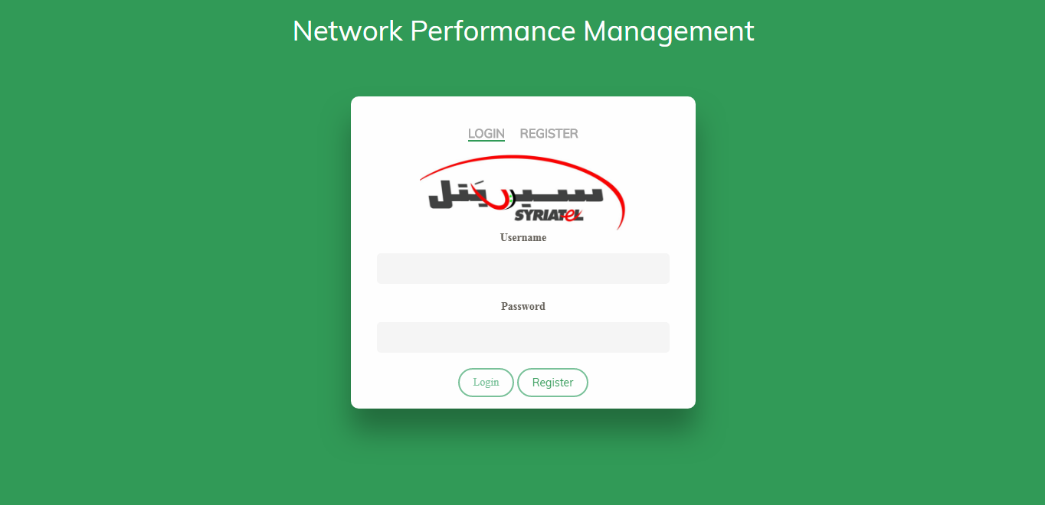

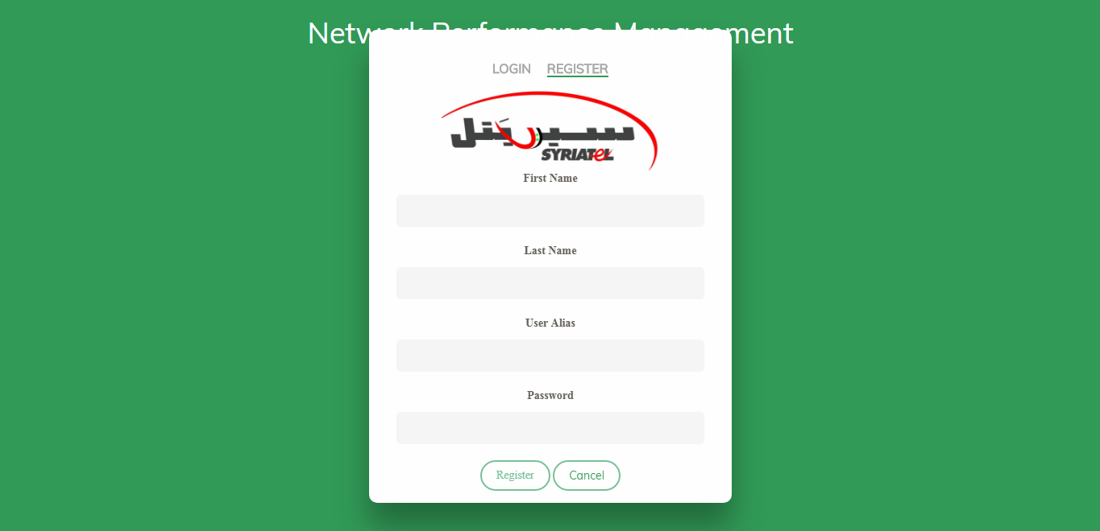

* Users can access to NPM main interface after login to Login-Register interface.
* Login process will be succeed by inserting ***Syriatel* *userAlias*** and ***optional* *password****.*
* User must Register to NPM system before login.
* User can communicate with **NPM Team** if password has been forgotten or unexpected error happened.
  1. Dashboard Interface

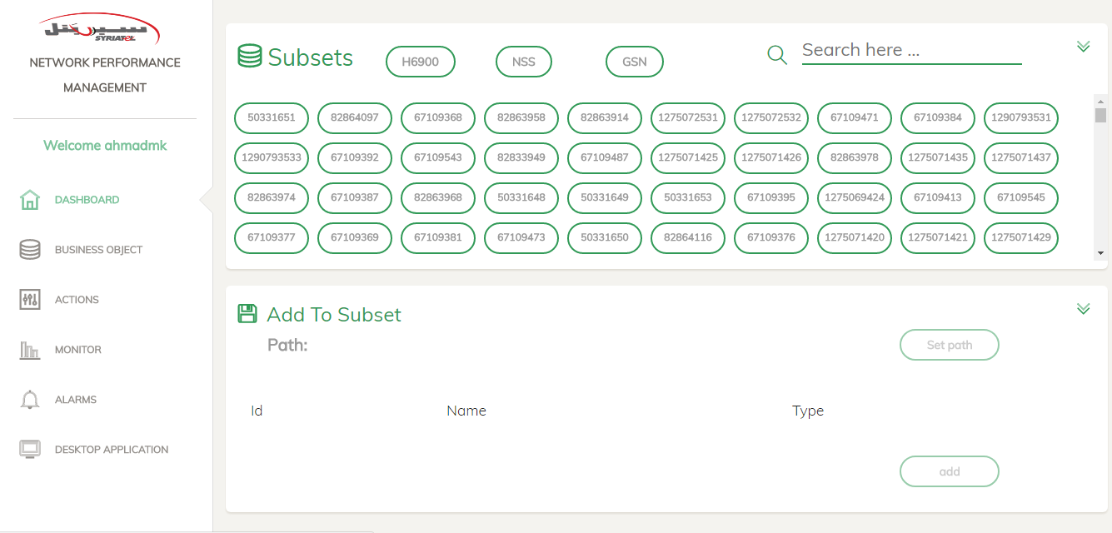

* The main interface which has all subsets and counters in NPM system.
* Dashboard interface allows user to add new subset , add counters or dimensions to exist subset.
  1. Business Object Interface

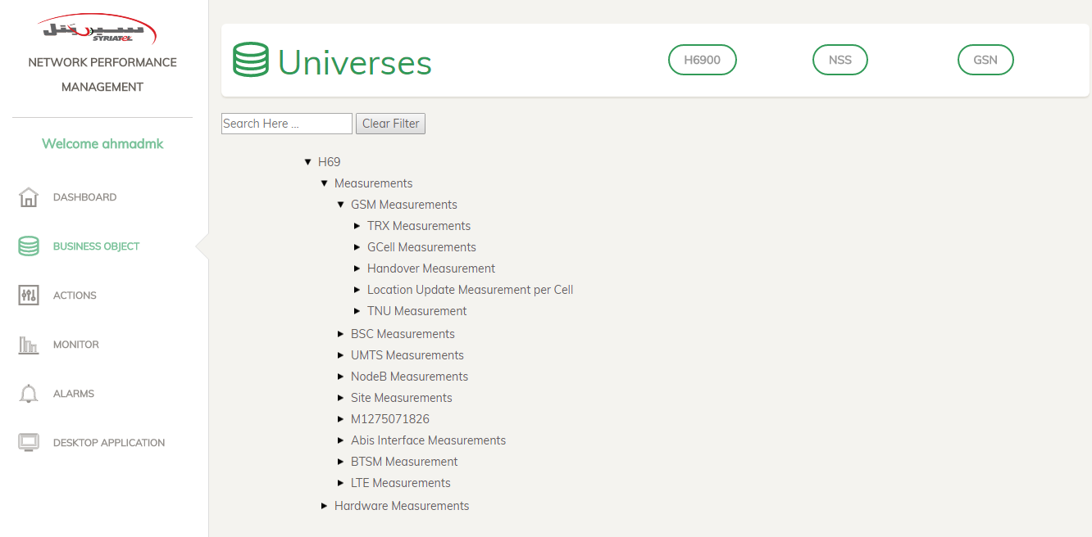

* Business object interface allow user to display more information about existed subsets and its related counters and dimensions.
* Business object interface allow user to do Deactivate counter , Change counter path processes on **NPM System**.
* User can search for specific counter by typing its name on the shown search box.
* User can switch between universes the shown top bar ( H6900 universe is the default one ).
  1. Actions Interface

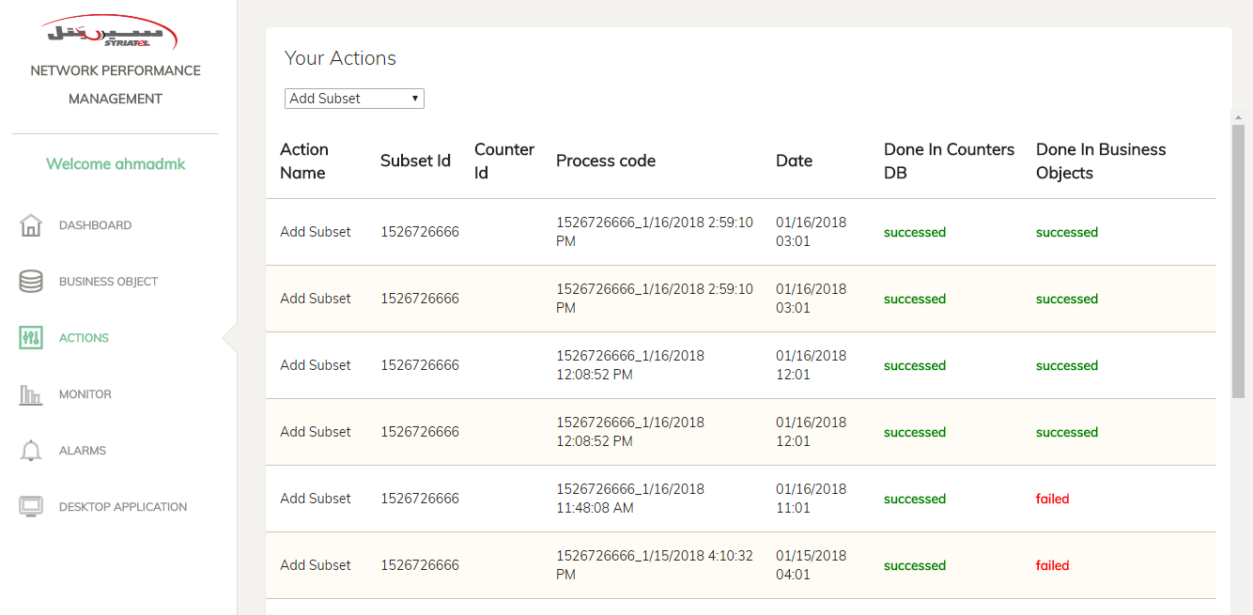

* Actions interface allows user to see all actions which has been done by him.
* User can filter on specific action from dropdown in the shown image above (filter on add subset action).
* Each row in actions table represent one action which was done by user before.
* Each row in actions table display process code which is important to use it to complete the action process in **NPM Desktop Application** side.
* **Done in Counters DB** column shows whether the action the changes has been updated in **Database** part successfully or not.
* **Done in Business Objects** column shows whether the changes has been updated in **Business Objects Application** or not.
* To update action’s changes on **Business Objects Application**, user must insert action’s process code in **NPM Desktop Application**.
  1. Monitor Interface

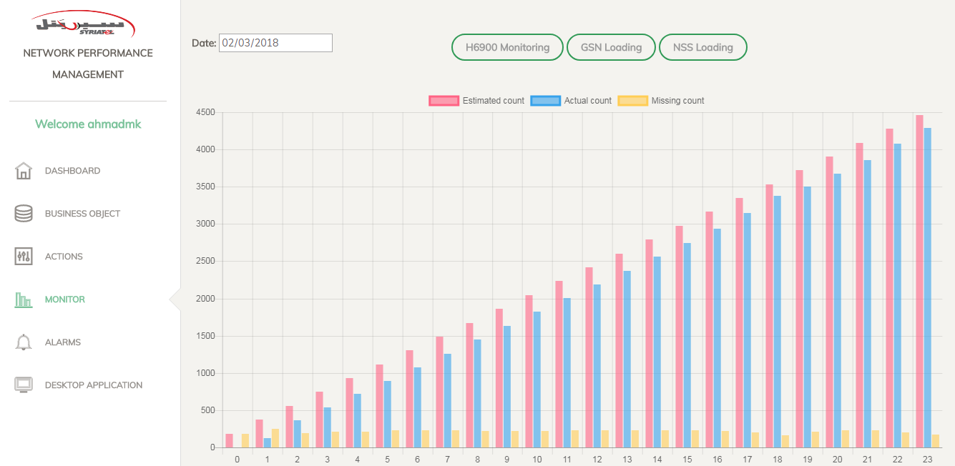

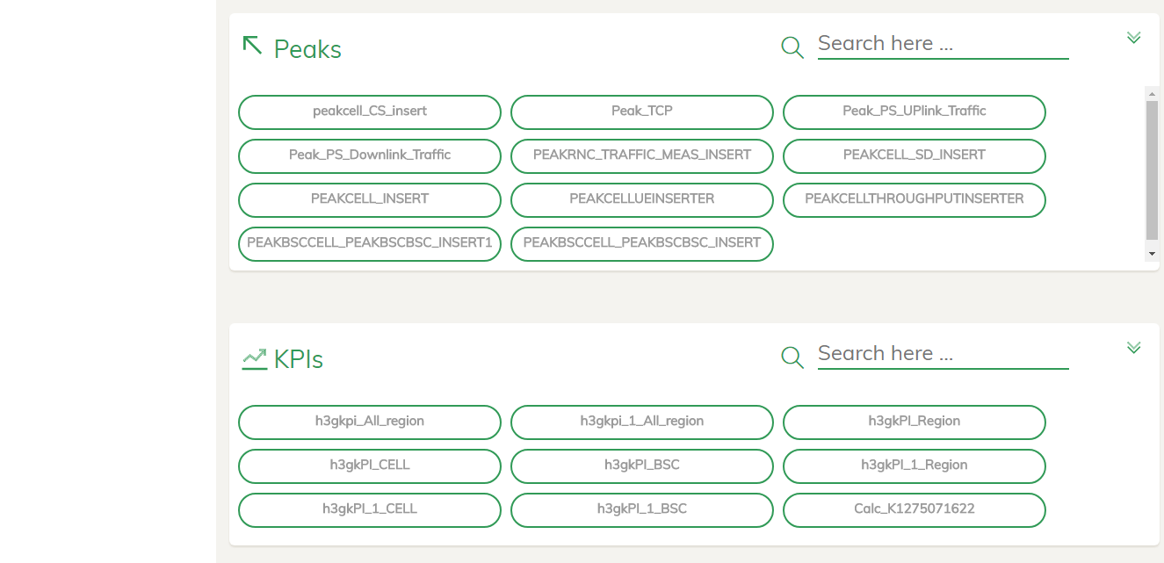

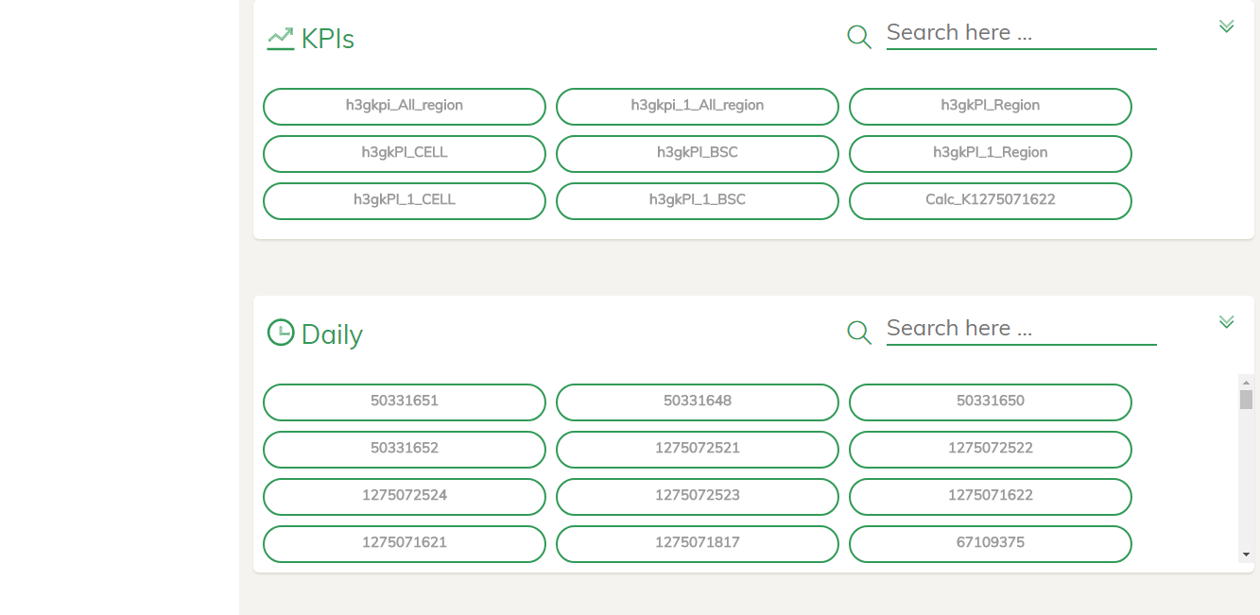

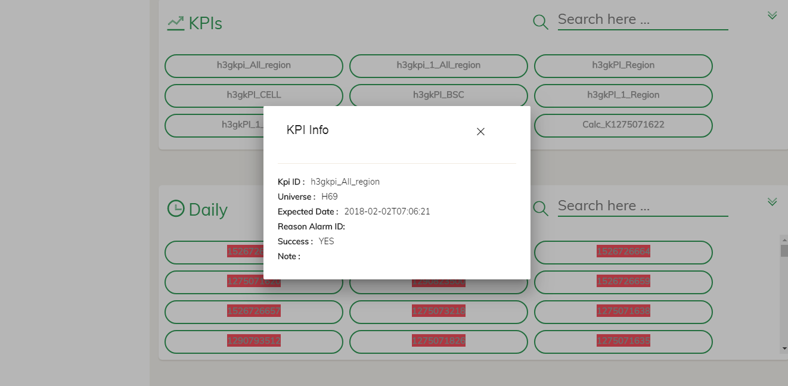

* Interface to monitor loading process, peaks, KPIs and accumulations in **Counters DB**.
* By selecting the date, universes names will be appeared, you can click on any one to get its item.
* In H6900, loading chart, peak, KPI, and daily accumulations will be shown.
* In peak, KPI, and daily accumulations, subset with red background has an alarm which refers to some missing, you can click to any to view some details.
* In chart, you have to click on the colors above to determine which bars you want to display.
  1. Alarms Interface

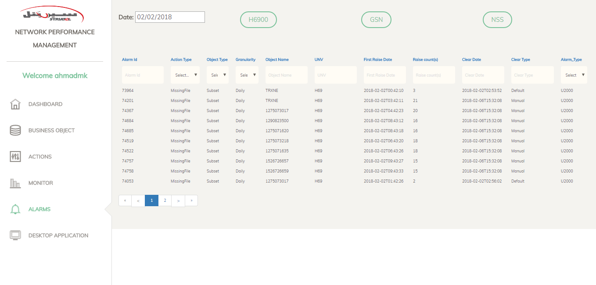

* Interface to view alarms related to missing issues with some details for each alarm.
* You can filter in the columns in two ways, list and type to search.
* For example: in Action Type you can filter by choosing **MissingFile** or **MissingData** from the list.
* In UNV you can filter by type the universe name in the top text box.
  1. Desktop Application Interface

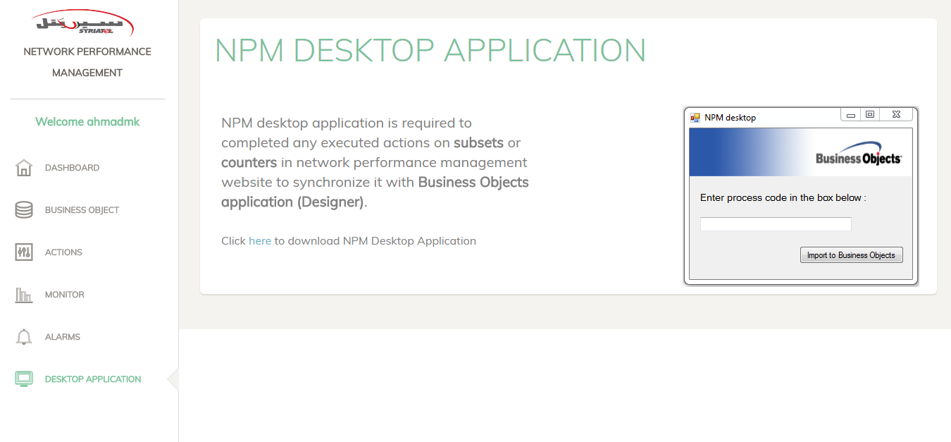

* Interface to download attached NPM desktop application.
* By clicking on here on the interface NPM desktop application will be downloaded in user PC.

1. NPM Actions
   1. Add Subset Action

* Dashboard interface is responsible for adding new subsets or adding counters, dimensions to exist subset.
* First, User has to select universe which has the required subset from the top bar (H6900-NSS-GSN).
* Then, search for required subset on the search bar above.
* Then, click on required subset to show its information with **Show Counters** and **Show Dimensions** buttons.

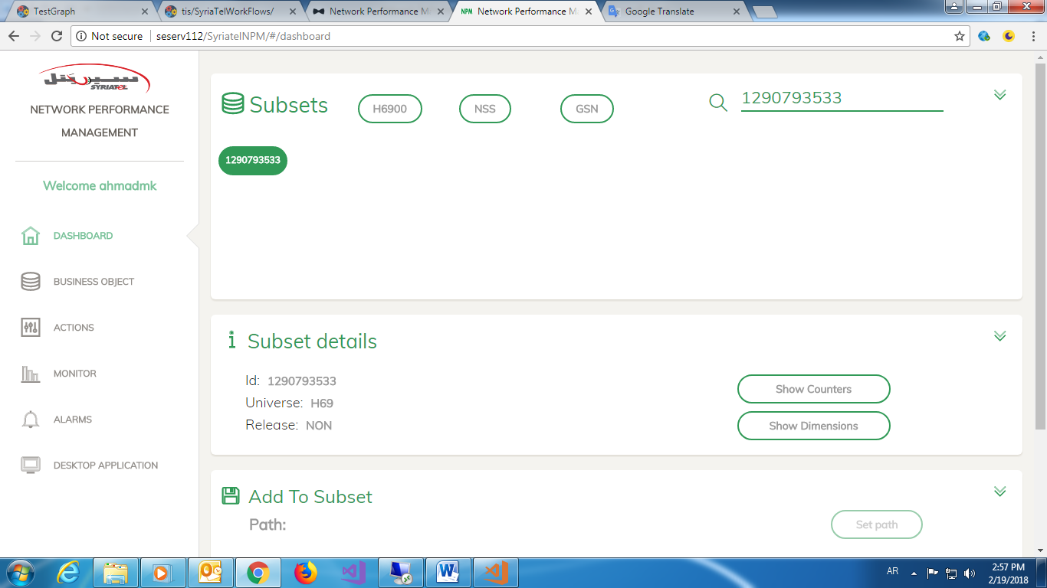

* By clicking on **Show Counters** button related counters for required subset will be displayed.
* By clicking on **Show Dimensions** button related dimensions for required subset will be displayed.

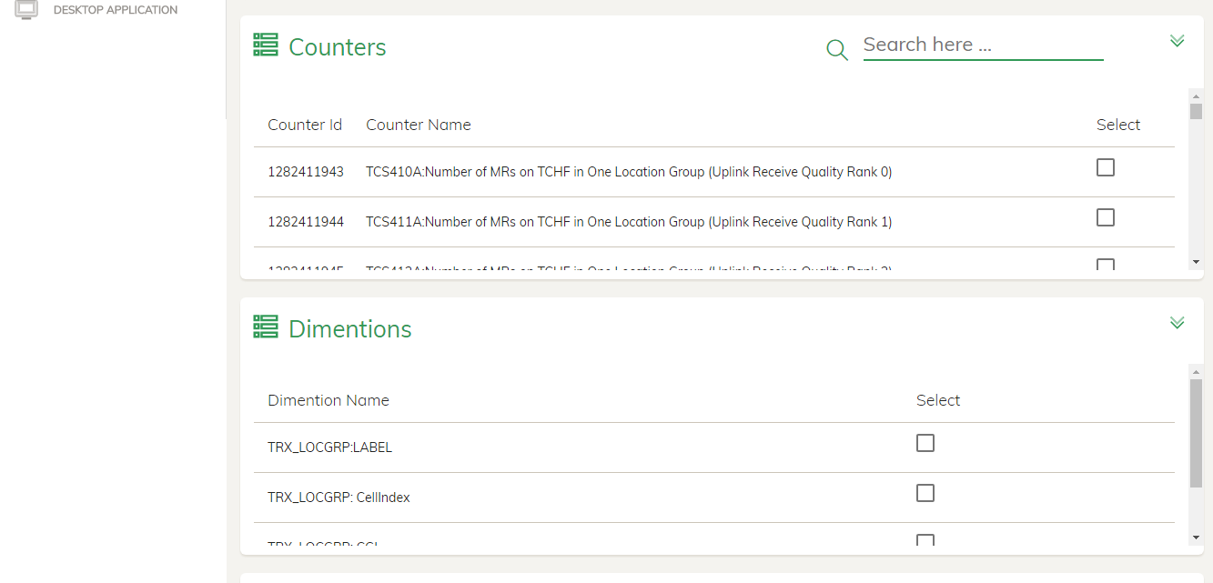

* User can choose any counter to add by clicking on the right checkbox.
* User can search for counter by type counter Id on the shown search bar.
* If counter doesn’t have checkbox on the right that means this counter is already added.
* After added required counters user must add all dimensions that related to selected subset.

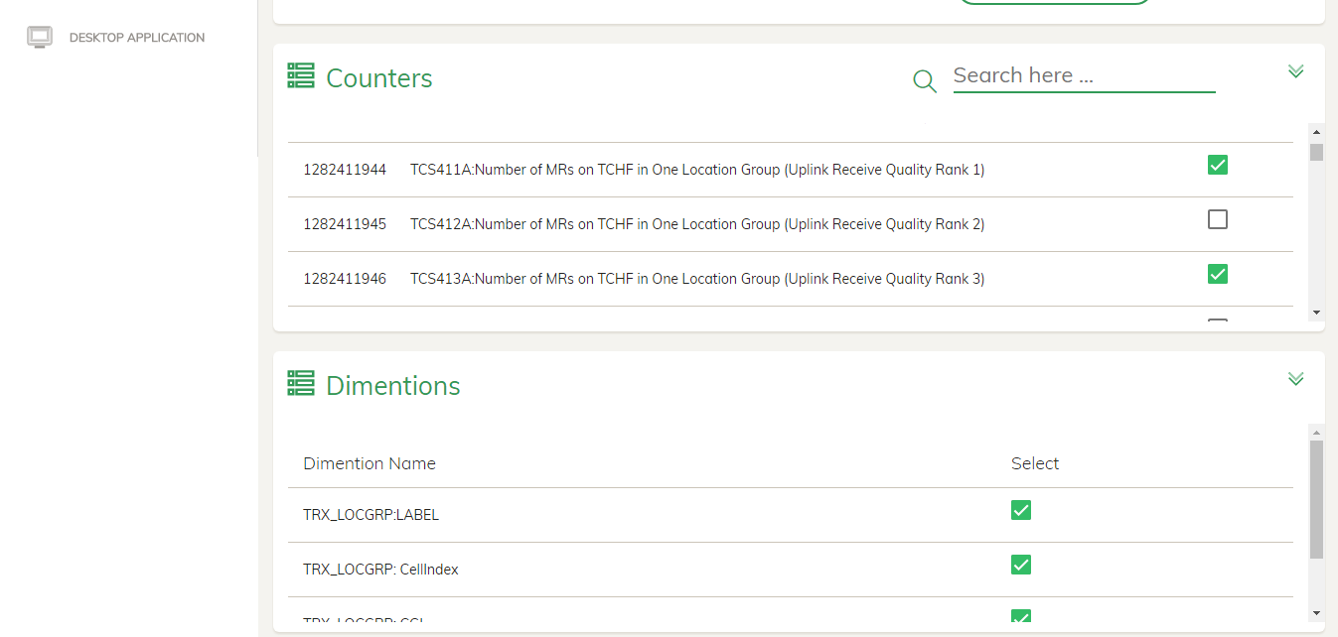

* When user clicks on **Show Dimensions** the below error might display.
* This error means that this subset isn’t activated from **Core Operation** side.
* User should communicate with **Core Operation** team to activate the required subset then try again.

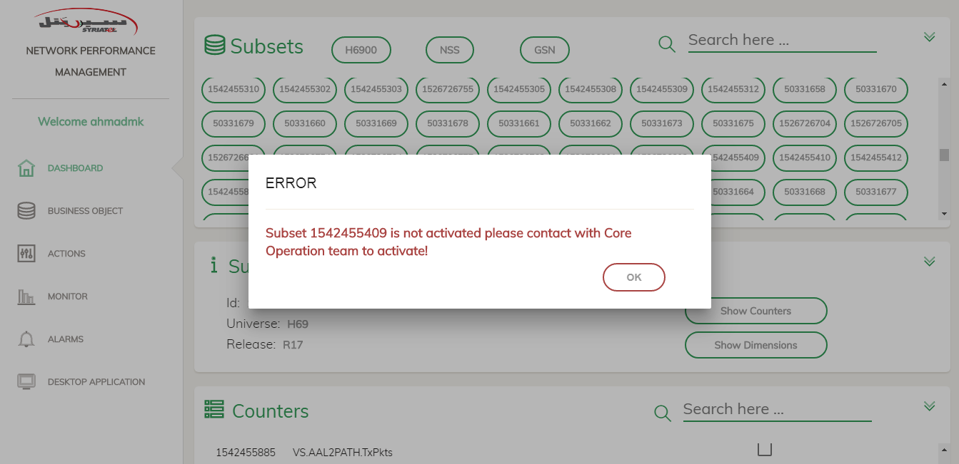

* After adding counters and dimensions, click on **Set Path** button to choose the path you want to add subset there.
* **Set Path** button will navigate to **Business Object Interface** to select path form there.

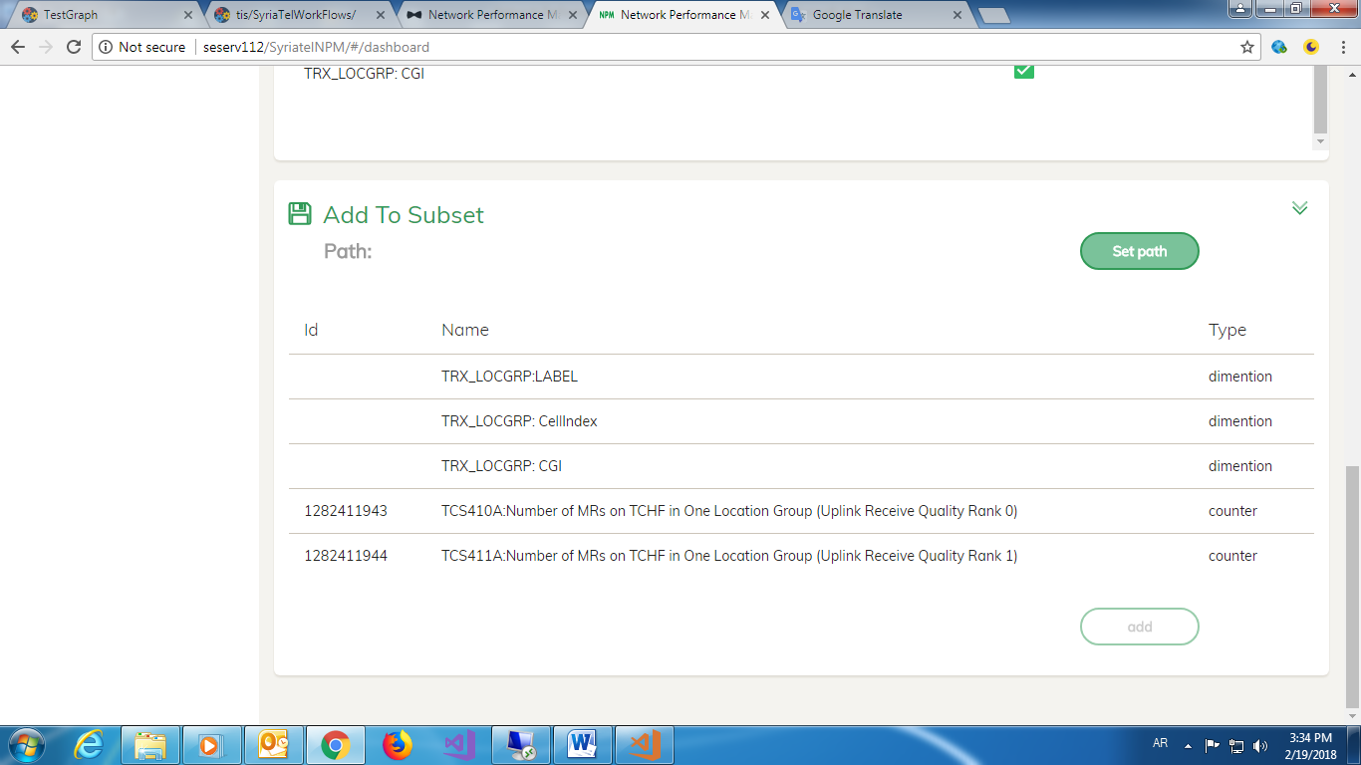

* Then, user select path from the shown tree by click on class wanted to add subset to.
* Then, massage box will display having the full path trace.
* User can add more classes to this path by inserting them in the shown text box with (/) between them.
* Then, click on **Add Counters Here** button to navigate to Dashboard page again with the selected path
* User can select path from **Business Object Interface** at first then navigate to **Dashboard Interface** and add counters and dimensions there.

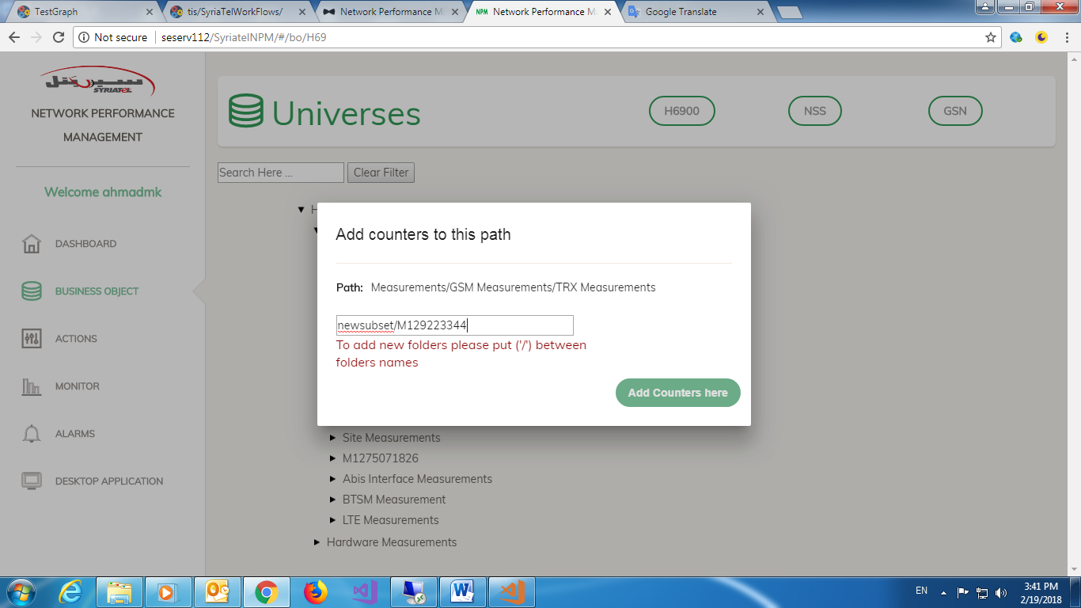

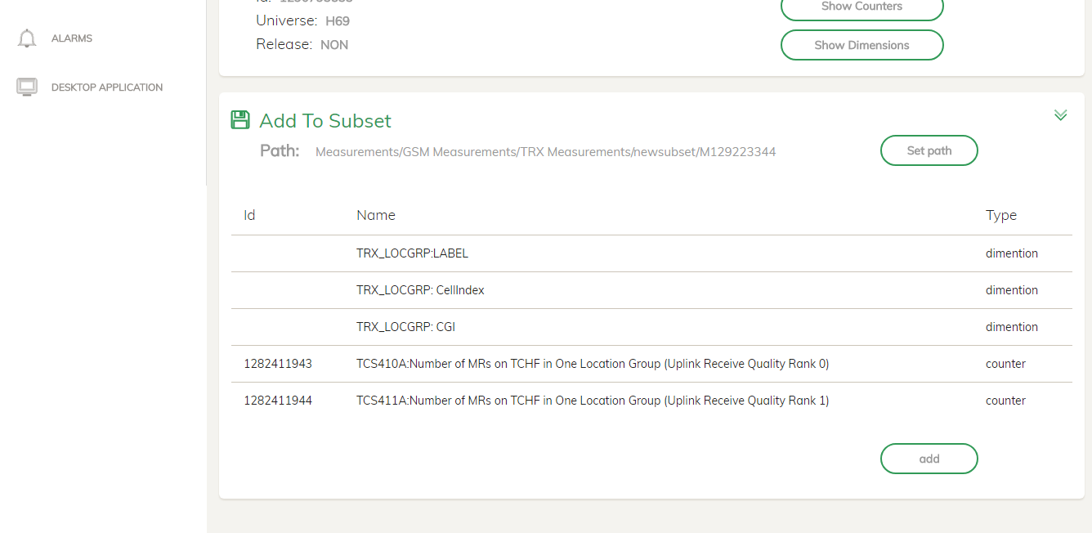

* Finally click on add button and wait until message displayed with the result.
* If the message saying that the process is succeeded then user should get process code from **Actions Interface** and complete the process in **NPM Desktop Application**.
* If the message saying that the process is failed then user should communicate with **NPM Team** to fix the problem.

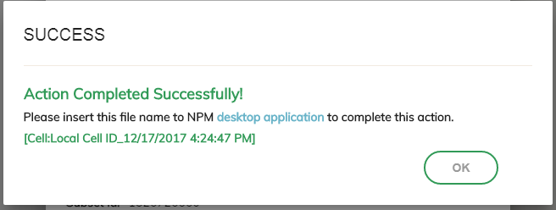

* In Actions Interface you will see that the process is succeeded in **Counters DB** column but failed in **Business Object** column because the process isn’t activated in **NPM Desktop Application** yet.

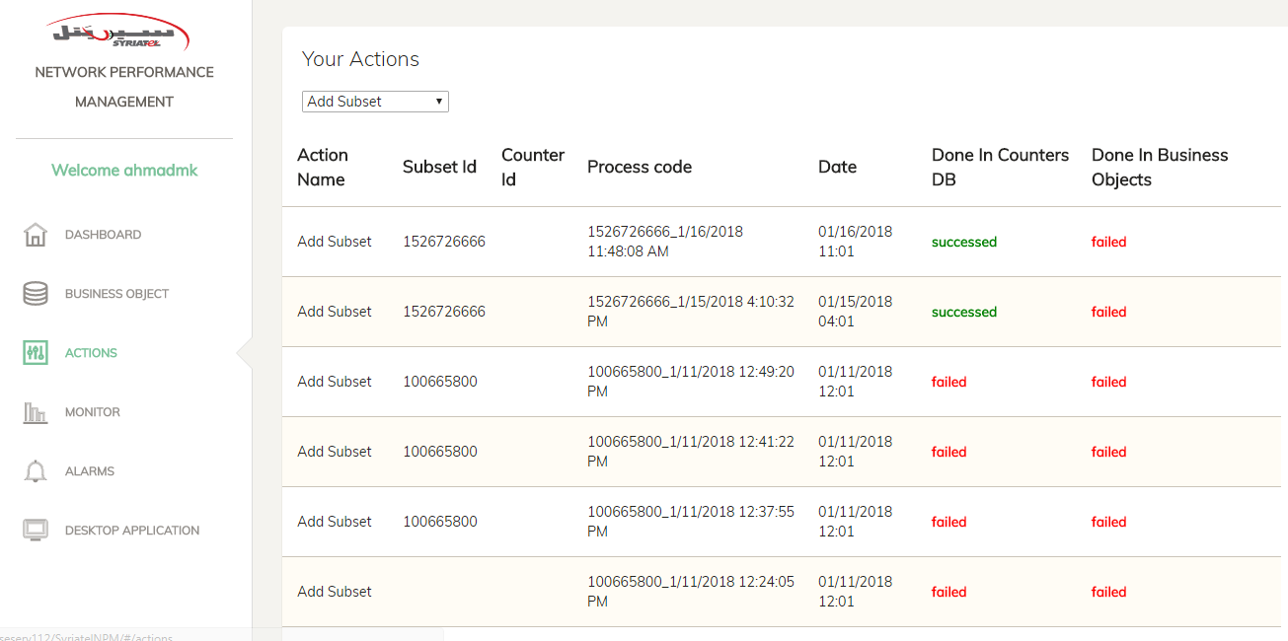

* To complete the process in **NPM Desktop Application** user has to install NPM Desktop Application.
* User can download **NPM Desktop Application** form **Desktop Application Interface**.
* Then, copy the process code and past it in the text box in **NPM Desktop Application** and click on Import to **Business Objects Interface**.
* Then some pop-up messages will be shown by desktop application so you have to confirm all of them.
* Then, a pop-up message will be shown to confirm save and export universe so you have to click **“OK”** button to complete adding action
* The previous step is very important to save data that has been added otherwise the process will be failed.
* Finally, pop-up message will be shown to inform that adding subset action is completed successfully and you can refresh the **Actions Interface** to see that the process is succeeded in both **Counter DB** and **Business Objects** sides.

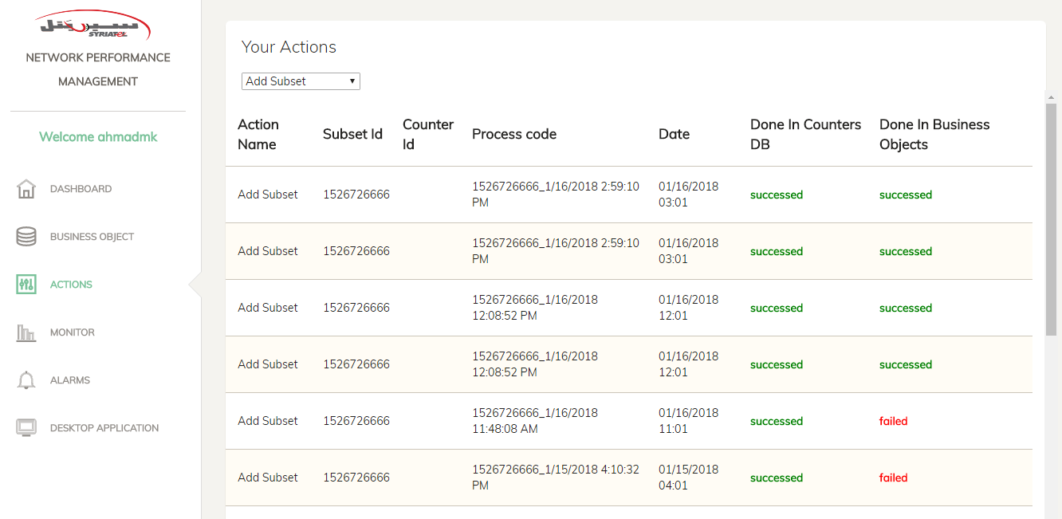

* You can communicate with NPM Team if **Adding Subset Action** is failed.
* More information about how to install **NPM Desktop Application** and required tools are in “Desktop Application” section in user guide.
  1. Deactivate Counter Action
* **Business Object Interface** is responsible for executing **Deactivate Counter Action**.
* First, User has to put counter wanted to deactivate in search box in business objects interface for example (S4561:AVERAGE DOWNLINK POWER IN THE CUSTOMIZED MR).

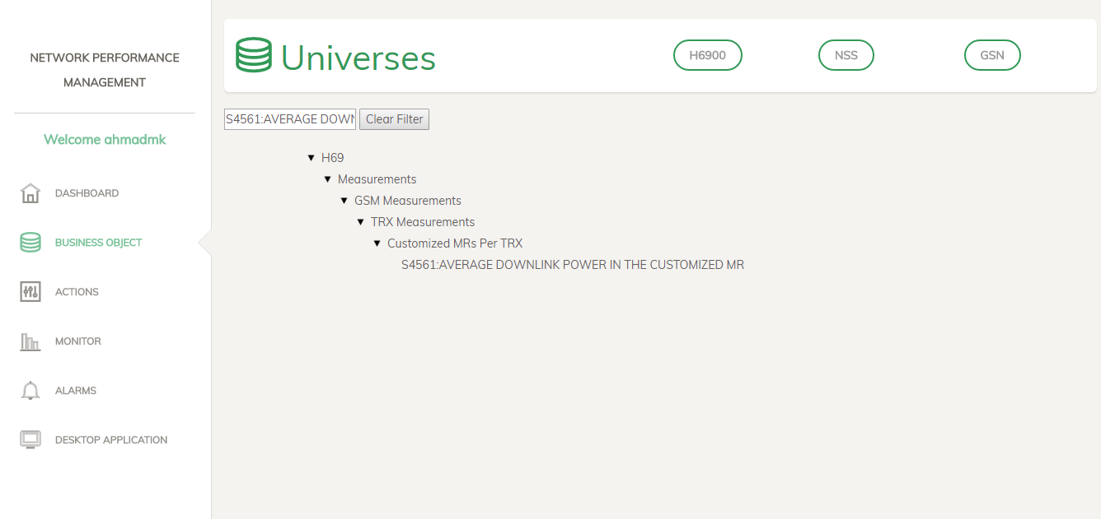

* Then, click on the counter user wants to deactivate
* Message will be shown with **Deactivate Counter** button in the bottom of the message.

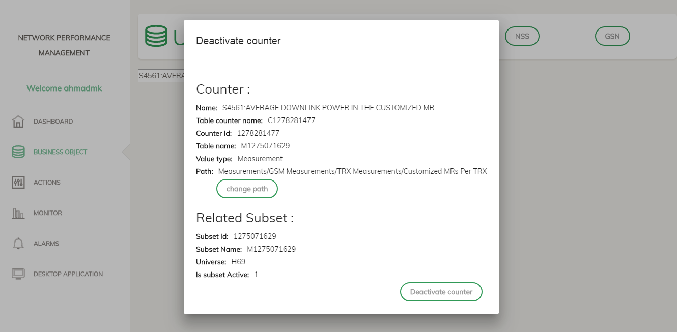

* Finally click on **Deactivate Counter** button and wait until message displayed with the result.



* If the message saying that the process is succeeded then user should get process code from **Actions Interface** and complete the process in **NPM Desktop Application**.
* If the message saying that the process is failed then user should communicate with **NPM Team** to fix the problem.
* To deactivate counter in **NPM Desktop Application** pleasecopy the process code from **Actions Interface** and complete the same steps which shown in **Add Subset Action**.
  1. Change Counter Path Action
* **Business Object Interface** is responsible for executing **Change Counter Path Action**.
* First, User has to put counter wanted to change path in search box in business objects interface for example (S4561:AVERAGE DOWNLINK POWER IN THE CUSTOMIZED MR).



* Then, click on the counter user wants to change path
* Message will be shown with **Change Path** button below the original counter path.



* Then, click on **Change Path** button to change the selected counter path.
* Then, The below Message box will be displayed, Click **Ok**.

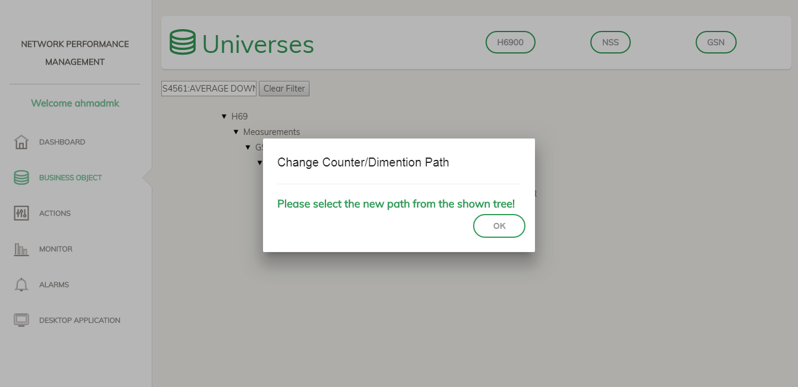

* Then, traverse inside the tree to select the new path you want to add the selected counter there.

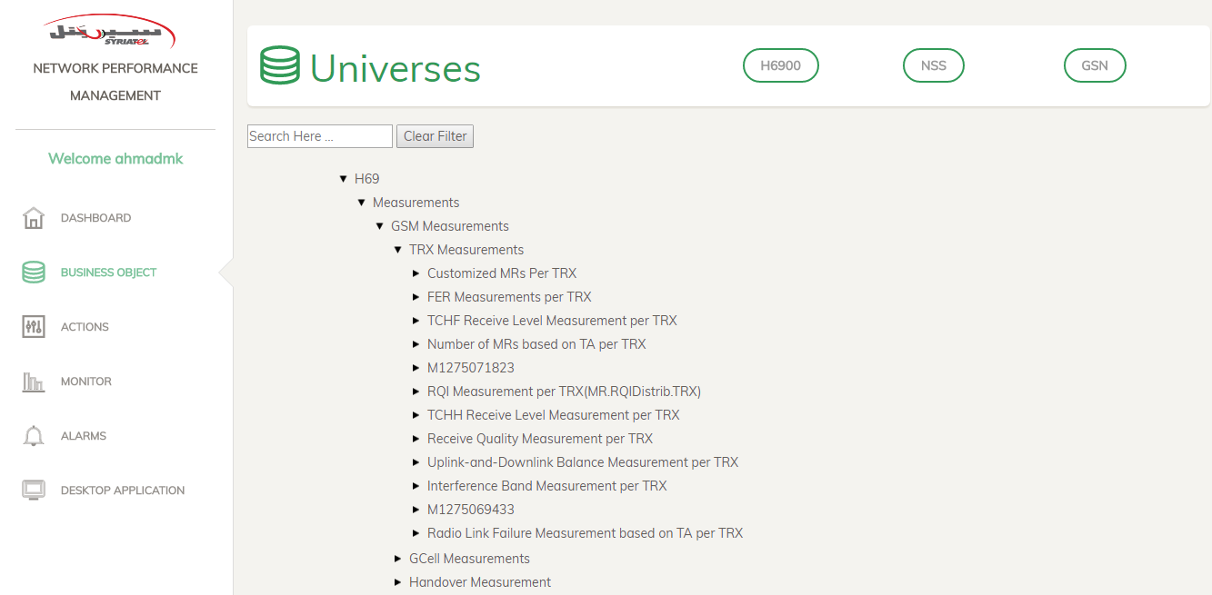

* Then, click on the class(folder) which user wants to add counter to it for example (FER Measurements per TRX).
* New message box will be displayed with two buttons on it.

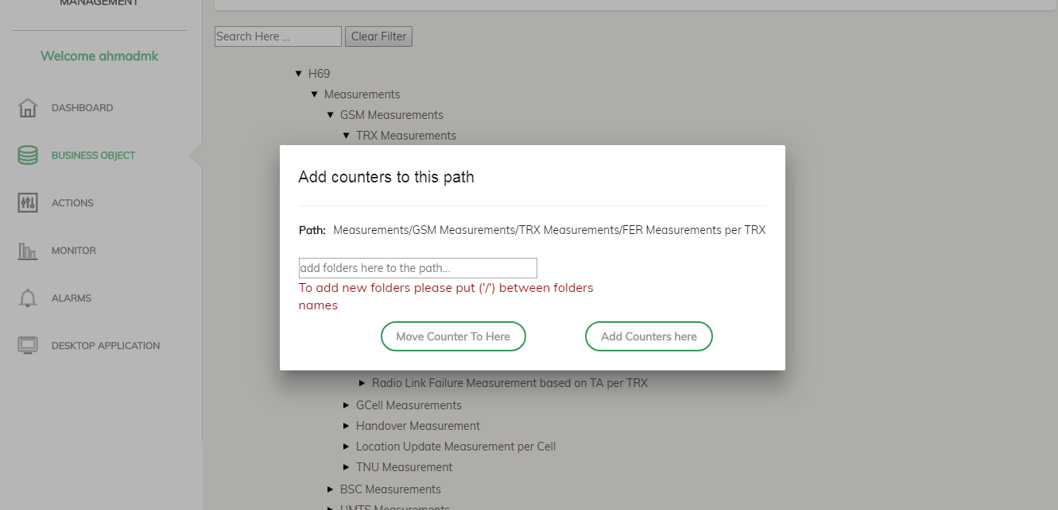

* User can add more classes to this path by inserting them in the shown text box with (/) between them.
* Finally, click on **Move Counter To Here** button to transfer the counter to the selected path “which also is written on the Message box above” and wait until message displayed with the result.



* If the message saying that the process is succeeded then user should get process code from **Actions Interface** and complete the process in **NPM Desktop Application**.
* If the message saying that the process is failed then user should communicate with **NPM Team** to fix the problem.
* To change counter path in **NPM Desktop Application** pleasecopy the process code from **Actions Interface** and complete the same steps which shown in **Add Subset Action**.

1. NPM Desktop Application
   1. How to install NPM

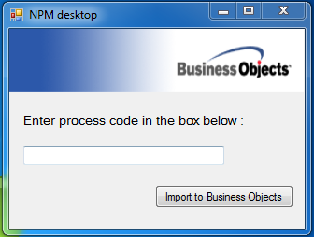

* NPM desktop application is required to completed any executed actions on subsets or counters in network performance management website to synchronize it with Business Objects application (Designer).
* You can download **NPM Desktop Application** from **Desktop Application Interface**.
* Unzip the downloaded file on your PC.
* Then click on setup.exe to install it.
* Finally, the application will be installed on your PC.
* Installing NPM desktop application doesn’t need local admin privilege but it will be needed to run it at the first time.
  1. NPM System Installation Requirements
* BusinessObjects Enterprise XI 3.1.
* .Net Framework 4.5.
* 8 GB RAM (recommended), 4 GB RAM at least.
* NPM Desktop Application.
* Google Chrome or Mozilla Firefox Browsers
* Full access privilege to “Business Objects” folder in “C:\Program Files (x86)” path.
* Ran NPM Desktop Application as a test with admin privilege at the first time (Read the steps in **Testing NPM Desktop Application** section).
* Helpdesk representative have to be familiar with the requirements above.
  1. Testing NPM Desktop Application
* Open NPM Desktop Application and write “test” on its box as the below picture.

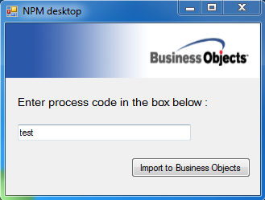

* Then the below messages will be displayed consecutively, so click **“Ok”** or **“Yes”** for all of them.

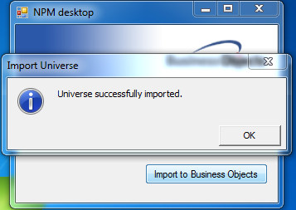

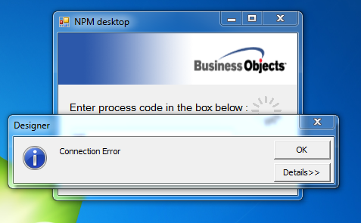

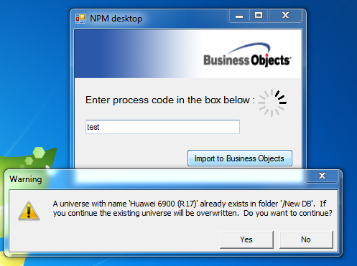

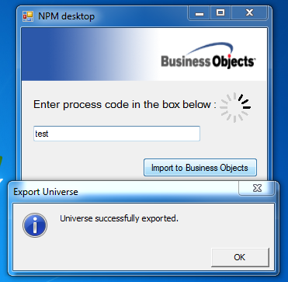

* Finally, message will be shown telling the user that the testing **NPM Desktop Application** is done successfully.

